AUTO TICKET CLASSIFICATION
USING FLOW DESIGNER
Final Project Documentation
ServiceNow Administrator Fundamentals / Naan Mudalvan Group Project

DOCUMENT STATUS | Final implementation completed and validated in the ServiceNow PDI; Update Set XML exported and GitHub packaging prepared.

Document control | Value
Project title | Auto Ticket Classification Using Flow Designer
Platform | ServiceNow Personal Developer Instance (PDI)
PDI instance | dev448174.service-now.com
Application | Global
Update Set | Project Update Set
Custom table | Incident Workflow (u_incident_workflow)
Flow | Auto Classify School IT Tickets
Prepared / updated | 4 October 2026
Version | 2.0 – final submission documentation
Update Set XML | sys_remote_update_set_be2eae9493b78f103788f2cfdd03d6e9.xml

Prepared from the supplied project document, ServiceNow Administrator Project Guide, common template ZIP, and the implementation evidence captured during the completed PDI build and testing.

Document Contents
This report follows the structure of the supplied NM final-report template and consolidates the project planning, requirements, design, implementation, testing, results, and submission evidence into one document.

Tip: open the document in Word and update the Table of Contents field if page numbers are not refreshed automatically.

Implementation Completion Snapshot
Area | Current status | Evidence / note
Requirements and planning | Complete | Problem statement, objectives, requirements, user stories, DFD, technology stack and plan documented.
Update Set | Complete / exported | Project Update Set completed; XML export captured as sys_remote_update_set_be2eae9493b78f103788f2cfdd03d6e9.xml.
Custom table | Complete | Incident Workflow table created with auto-numbering and required fields.
Choice fields | Complete | Category, Subcategory and State choices configured.
Dependency | Complete | Subcategory is dependent on Category with four documented mappings.
Flow Designer | Complete / active and tested | Auto Classify School IT Tickets is configured with a Record Created trigger, four classification branches, Update Record actions and Send Email.
Email action | Configured and executed | Send Email is configured for Caller → Email. Email log/execution evidence confirms action execution; external mailbox delivery is not independently claimed.
Final activation | Complete | The final flow is active; a real-time ticket creation test successfully triggered automated classification.
Update Set XML | Pending | Set State to Complete, save, then Export to XML.
GitHub / SkillWallet | Pending | Package final documentation, evidence and XML, then submit links.

This status deliberately distinguishes a configured/tested PDI build from the final submission artifact. No fabricated screenshots, XML, delivery confirmations or performance claims are used.

1. INTRODUCTION

1.1 Project Overview
The school IT helpdesk scenario described in the project brief involves recurring requests related to Wi-Fi connectivity, projector failures, password or login problems, and slow computers. The existing manual process requires an IT staff member to interpret the request and choose a category and subcategory. The proposed solution uses ServiceNow Flow Designer to classify a newly created ticket using predefined keyword rules and then update the ticket record.
The implementation is deliberately no-code and rule-based. It does not train or deploy a machine-learning or NLP model. The project uses a custom Incident Workflow table, dependent choice fields, a record-created Flow Designer trigger, four classification branches, Update Record actions, and a Send Email action.

1.2 Purpose
- Standardize classification for four common school IT request types.
- Reduce repetitive manual selection of Category and Subcategory.
- Keep classification rules visible and maintainable inside Flow Designer.
- Store ticket data in a structured custom table with consistent choices.
- Provide an automated acknowledgement email action to the caller.
- Produce traceable evidence, testing results, and an Update Set XML for handover.

2. IDEATION PHASE

2.1 Problem Statement
The school IT helpdesk receives multiple incident requests daily from students and teachers, such as Wi-Fi issues, projector failures, password problems, and slow computers. IT staff currently review each request and manually assign a category. This creates repetitive handling effort, can lead to inconsistent categorization, and can delay routing. The project therefore automates classification using ServiceNow Flow Designer and a defined keyword-to-category mapping.

2.2 Empathy Map Canvas
Stakeholder | Says | Thinks | Does | Feels
Student / teacher / staff requester | “Wi-Fi is not connecting”; “I forgot my password.” | I need help quickly and do not know the technical category. | Submits a ticket with a short description and details. | Frustrated when an issue interrupts class or work.
IT support technician | “Which team should handle this?” | I need consistent ticket information to prioritize work. | Reads and classifies incoming requests. | Under pressure during busy periods.
IT coordinator / administrator | “Are tickets being categorized consistently?” | I need standard records and visibility. | Reviews ticket data and workflow outcomes. | Concerned about consistency and maintainability.

Empathy-map entries are scenario-based design assumptions, not interview findings.

2.3 Brainstorming and Idea Prioritization
Idea | How it addresses the problem | Fit with supplied project brief
Rule-based Flow Designer classification | Checks ticket text and updates Category/Subcategory automatically. | Directly matches the brief; selected implementation.
Automatic assignment to support groups | Routes tickets after classification. | Useful extension; not required for the current build.
SLA tracking and escalation | Adds response and resolution timing. | Future enhancement; not part of the current scope.
Machine-learning / NLP classifier | Learns categories from historical tickets. | Out of scope; the supplied project is explicitly no-code and rule-based.
Predictive intelligence | Uses advanced ServiceNow intelligence capabilities. | Future enhancement; not required for submission.

The rule-based Flow Designer approach was used because it directly satisfies the supplied project brief without introducing model training, external datasets, or scripting dependencies.

3. REQUIREMENT ANALYSIS

3.1 Customer Journey Map
Stage | Requester experience | System / support action | Expected outcome
1. Identify issue | Recognizes a Wi-Fi, projector, password/login, or slow-computer problem. | No system action yet. | Clear issue description is available.
2. Submit ticket | Provides caller and short description. | Incident Workflow record is created and numbered. | Ticket is stored with a unique identifier.
3. Automatic classification | Does not need to choose technical category. | Flow Designer evaluates the short description and selects a branch. | Category/Subcategory are populated for recognized inputs.
4. Acknowledgement | Receives a ticket acknowledgement through the configured email action. | Send Email action targets Caller → Email. | Notification action is recorded in the email subsystem.
5. IT review | Waits for support handling. | IT support reviews the classified ticket. | Consistent information supports routing and handling.
6. Unmatched issue | Provides an issue that does not match the four rules. | No unrelated category should be forced; manual review remains possible. | Ticket remains reviewable.

3.2 Solution Requirements
ID | Requirement | Acceptance condition
FR-01 | Store ticket records in the Incident Workflow table. | A ticket record can be created and receives an auto-number.
FR-02 | Generate unique ticket numbers. | New records receive unique numbers such as INC0001001.
FR-03 | Provide caller and issue-detail fields. | Caller, Short Description and Description fields are available.
FR-04 | Provide four Category choices. | Network, Hardware, Access and Performance are configured.
FR-05 | Provide four mapped Subcategory choices. | Wi-Fi, Projector, Forgot Password and Slow Computer are configured.
FR-06 | Use dependent choice logic. | Each Subcategory is associated with the correct Category.
FR-07 | Run classification on record creation. | Flow trigger is Record Created with Category empty/null.
FR-08 | Update Category and Subcategory automatically. | Each matching branch uses Update Record on the triggering record.
FR-09 | Send an email notification. | Send Email action targets Caller → Email with the required subject.
FR-10 | Provide evidence for verification. | Screenshots, execution details, email logs and XML are retained for submission.

3.3 Data Flow Diagram
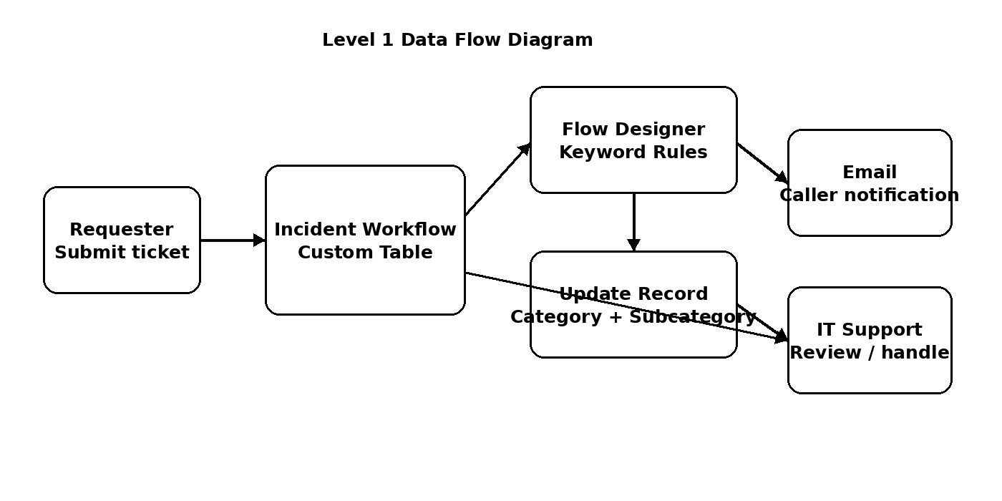
Figure 1. Data flow from ticket submission through classification, notification and IT review.

3.4 Technology Stack
Technology / component | Use in this project | Status
ServiceNow Platform | Custom ticket table, fields, choices, references and records. | Configured in PDI
Flow Designer / Workflow Studio | Record-created trigger, conditional classification branches and record updates. | Configured and test-executed
ServiceNow Email subsystem | Send Email action and email log evidence. | Configured; external delivery not claimed
Update Sets | Capture configuration changes and export XML for handover. | Configured, completed and XML exported
GitHub | Versioned project documentation, evidence and Update Set XML. | Repository packaging in progress
Microsoft Word / PDF | Formal project documentation and final-report packaging. | Final DOCX prepared; PDF can be generated for submission

3.5 User Stories and Acceptance Criteria
Story | User story | Acceptance criteria
US-01 | As an IT support user, I want to create a ticket so the issue is recorded. | Record saves and an auto-number is generated.
US-02 | As a support user, I want a Wi-Fi issue classified automatically. | Wi-Fi text maps to Network / Wi-Fi.
US-03 | As a support user, I want a projector issue classified automatically. | Projector text maps to Hardware / Projector.
US-04 | As a support user, I want a password/login issue classified automatically. | Password/login text maps to Access / Forgot Password.
US-05 | As a support user, I want a slow-computer issue classified automatically. | Slow/hanging text maps to Performance / Slow Computer.
US-06 | As a requester, I want an email notification when the workflow processes my ticket. | Configured Send Email action runs for the test record.
US-07 | As an administrator, I want unknown issues to remain reviewable. | Unmatched text is not assigned an unrelated category.
US-08 | As an evaluator, I want verifiable evidence of the implementation. | Screenshots, test results and Update Set export are included.

4. PROJECT DESIGN

4.1 Problem-Solution Fit
Problem / need | Designed response | Evidence / validation
Manual classification takes time. | Flow Designer evaluates ticket text at creation. | Flow test execution shows branch evaluation and Update Record completion.
Category/Subcategory can be inconsistent. | Dependent choices and fixed mappings standardize values. | Configured dependency and choice mappings.
Requester needs acknowledgement. | Send Email action targets caller email. | Email action configuration and email log record.
Rules need maintainability. | Logic is visible as If / Else If branches in Flow Designer. | Flow canvas screenshot.
Configuration must be transferable. | Update Set captures platform configuration. | Project Update Set; final XML export pending.

4.2 Proposed Solution
- Create an Incident Workflow record with Caller and Short Description.
- Use the Record Created trigger only when Category is empty/null.
- Evaluate the Short Description using four rule branches.
- Update Category and Subcategory on the triggering record.
- Send an acknowledgement email to the caller.
- Verify the result through the record, flow execution details and email logs.
- Retain unmatched descriptions for review rather than forcing an unrelated category.

4.3 Solution Architecture
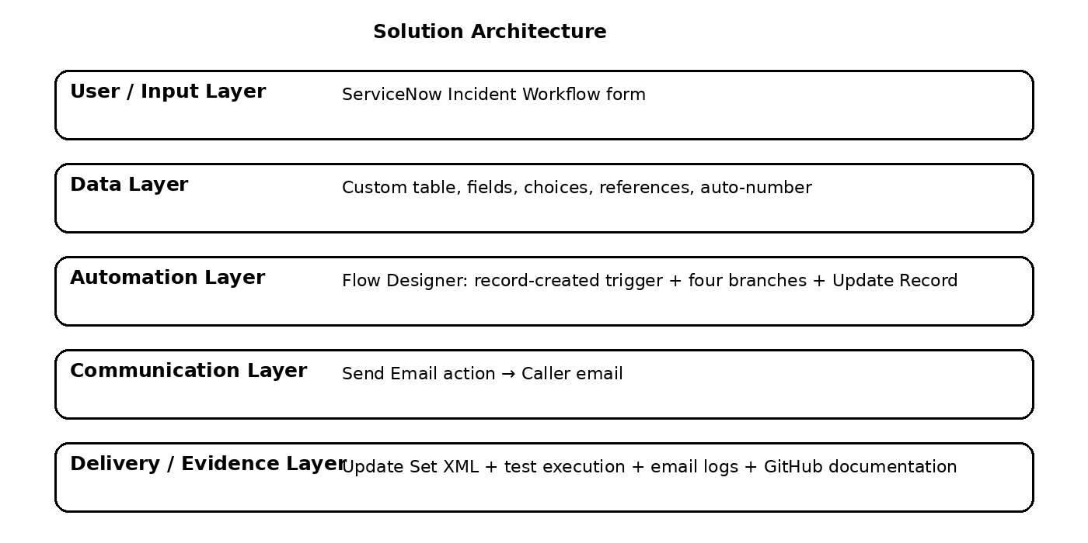
Figure 2. Layered solution architecture for the implemented ServiceNow workflow.

4.4 Data Model and Field Configuration
Field label | Internal name / type | Configured value / purpose
Number | Auto Number | Prefix INC; 7 digits; starts at 1000.
Caller | u_caller — Reference | Reference to sys_user / User.
Category | u_category — Choice | Network, Hardware, Access, Performance.
Subcategory | u_subcategory — Choice | Wi-Fi, Projector, Forgot Password, Slow Computer; dependent on Category.
Short Description | u_short_description — String | Keyword source used by the Flow Designer branches.
Description | String | Additional ticket detail.
State | u_state — Choice | New, In progress, On hold, Resolved, Closed.
Assigned Group | Reference | Reference to Group / sys_user_group.
Assigned to | Reference | Reference to User / sys_user.

The custom table is named Incident Workflow with internal name u_incident_workflow. Auto-numbering is enabled. Standard ServiceNow system columns are also present on the table.

4.5 Category / Subcategory Dependency
Category | Allowed Subcategory | Backend value used for dependency
Network | Wi-Fi | network → wifi
Hardware | Projector | hardware → projector
Access | Forgot Password | access → forgot_password
Performance | Slow Computer | performance → slow_computer

The dependency prevents the form from presenting unrelated Subcategory values for a selected Category. This supports the data-integrity requirement in the supplied project brief.

4.6 Flow Designer Logic
Flow element | Configured implementation
Flow name | Auto Classify School IT Tickets
Application | Global
Trigger | Record Created
Trigger table | Incident Workflow [u_incident_workflow]
Trigger condition | Category is empty/null
Branch 1 | Short Description contains Wi-Fi OR Network → Category Network; Subcategory Wi-Fi
Branch 2 | Short Description contains Projector → Category Hardware; Subcategory Projector
Branch 3 | Short Description contains Forgot Password → Category Access; Subcategory Forgot Password
Branch 4 | Short Description contains Slow Computer → Category Performance; Subcategory Slow Computer
Email action | Send Email → Caller → Email
Email subject | Your Request for the issue has been submitted.

During implementation, a small set of additional keyword variants was considered to improve practical coverage. The final documented core mapping remains aligned with the supplied project brief. Broad standalone words such as “slow” or “password” should be added only after deliberate testing because they can create unintended matches.

4.7 Email Notification Design
- Action: Send Email.
- Recipient: Caller → Email.
- Subject: Your Request for the issue has been submitted.
- Body: Ticket confirmation message.
- Evidence: the email log contains records with the required subject and send-ready status.
- Limitation: send-ready/log evidence is not treated as proof of delivery to an external mailbox.

5. PROJECT PLANNING & SCHEDULING

5.1 Project Planning
Milestone | Work items | Current completion evidence
1. Requirement Analysis & Planning | Business use case, problem statement, empathy map, brainstorming, solution requirements, user stories, DFD, technology stack. | Documented in this report and supplied phase templates.
2. Backend Development & Configuration | Update Set, custom table, numbering, fields, choices, dependency. | PDI configuration completed and visually verified.
3. Flow Designer & Email Notification | Trigger, four branches, Update Record actions, email action, testing. | Flow canvas and completed execution evidence captured.
4. Testing, Validation & Security | Functional tests, data validation, dependency, email and privacy review. | Core end-to-end path validated; Wi-Fi real-time classification verified; projector path previously verified; remaining edge-case tests are documented as not executed.
5. Deployment & Final Documentation | Complete Update Set, export XML, GitHub packaging and SkillWallet submission. | Update Set XML exported; final report prepared; GitHub packaging underway.

5.2 Project Schedule
Day / phase | Planned activity | Deliverable
Day 1 | Requirement analysis and ideation | Problem statement, empathy map, brainstorming, requirements
Day 2 | Backend configuration | Update Set, table, fields, choices, dependency
Day 3 | Automation | Flow Designer branches, Update Record, email action
Day 4 | Testing and submission preparation | Test evidence, report, XML export, GitHub package

5.3 Risk Register
Risk | Impact | Mitigation / actual response
PDI availability delay | Blocks live configuration and screenshots. | PDI became available and was used for the implementation.
Keyword overlap / ambiguous text | Incorrect branch could be selected. | Use deliberate branch order and avoid overly broad keywords.
Case variation in text | A keyword may not match as expected. | Test case variations and add explicit variants only where justified.
Email sending restrictions | External delivery may not be demonstrable. | Use email logs and execution evidence; do not claim external delivery without evidence.
Update Set incomplete | Handover artifact could miss changes. | Complete the Update Set, export XML and verify the downloaded file before submission.
Sensitive data in GitHub | Privacy exposure. | Use fictional test data and redact account details, credentials and personal identifiers.

6. FUNCTIONAL AND PERFORMANCE TESTING

6.1 Testing Approach
Testing follows the project brief: verify record creation, auto-numbering, category/subcategory accuracy, reference fields, flow execution and email behavior. The supplied final-report template also calls for functional/performance testing. Because this project is a small no-code workflow rather than a load-tested production service, no formal throughput benchmark or stress test was performed. Diagnostic execution timing from the Flow Designer test run is recorded only as an observation, not as a performance guarantee.

6.2 Test Cases and Actual Results
Test ID | Input / action | Expected result | Actual result / status
TC-01 | Create ticket with “WiFi not working in library”. | Network / Wi-Fi; email action runs. | PASS – Wi-Fi/Network branch evaluated correctly; Update Record and Send Email completed. The final real-time creation test also triggered the flow successfully.
TC-02 | Create ticket with “Projector not turning on”. | Hardware / Projector; email action runs. | PASS – Projector → Hardware / Projector classification was verified during the live PDI test sequence.
TC-03 | Create ticket with “I forgot my password and cannot log in”. | Access / Forgot Password. | NOT EXECUTED – Access / Forgot Password branch is configured but no final live evidence was captured.
TC-04 | Create ticket with “Computer is slow and keeps hanging”. | Performance / Slow Computer. | NOT EXECUTED – Performance / Slow Computer branch is configured but no final live evidence was captured.
TC-05 | Create unrelated ticket text. | No unrelated forced classification; manual review remains possible. | NOT EXECUTED – No-match behavior was not separately executed; the flow is intended not to force an unrelated classification.
TC-06 | Create mixed-case keyword such as “WIFI not working”. | Same mapping if matching behavior supports the variation. | NOT EXECUTED – Mixed-case behavior was not separately executed as a dedicated test.
TC-07 | Create ticket with blank issue text if allowed. | No incorrect classification. | NOT EXECUTED – Blank/missing text behavior was not separately executed.
TC-08 | Create recognized ticket with valid caller email. | Send Email action runs and email record is generated. | PASS AT ACTION/LOG LEVEL – Send Email completed in captured executions and the required subject appears in the email log. External delivery is not independently claimed.
TC-09 | Check dependency for all four categories. | Only the correct mapped subcategory is available/valid. | PASS AT CONFIGURATION LEVEL – Subcategory dependency is configured for all four required Category mappings.
TC-10 | Review Flow Designer test execution. | Flow test completes and execution details are visible. | PASS – Final flow is active and completed executions are visible in Flow history.

Observed diagnostic timing: the captured completed Flow Designer test run reported approximately 6500 ms total runtime. This is a single diagnostic execution and must not be presented as a production performance benchmark.

6.3 Data Validation and Security
- Auto-numbering generated INC0001001 during the test flow setup, demonstrating that the custom table numbering is functioning.
- Category and Subcategory are choice fields with the four required mappings.
- Subcategory dependency is configured against Category.
- Caller and Assigned To reference ServiceNow users; Assigned Group references ServiceNow groups.
- Test records should use non-sensitive or fictional data before public GitHub screenshots are uploaded.
- No passwords, session cookies, private credentials or secrets should be committed to the repository.
- The PDI is a development environment and is not treated as a production school helpdesk.

6.4 Performance Testing
Check | Observation | Interpretation
Single flow execution | Completed test run reported about 6500 ms. | Confirms the flow can complete a controlled test run; not a load benchmark.
Branch evaluation | WiFi/Network branch evaluated True; unrelated Else If branches were Not Run. | Expected short-circuit behavior for the matched branch.
Email action | Send Email action completed in the captured execution. | Action execution was successful; external mailbox delivery is not claimed.
Load / concurrency | No formal concurrent-load test executed. | Outside the scope of the supplied project brief and PDI demonstration.

7. RESULTS

7.1 Output / Implementation Results
The implemented PDI contains the requested custom ticket structure and the Flow Designer automation. The captured execution evidence shows a completed test run in which the WiFi/Network condition evaluated True, the corresponding Update Record action completed, the other Else If branches were not run, and the Send Email action completed. The email log also contains records using the exact subject required by the project document.
The implementation therefore demonstrates the central end-to-end mechanism. Final submission is still dependent on the final Flow activation, completion of the Project Update Set, XML export, and packaging of the documentation/evidence into GitHub.

7.2 Output Screenshots
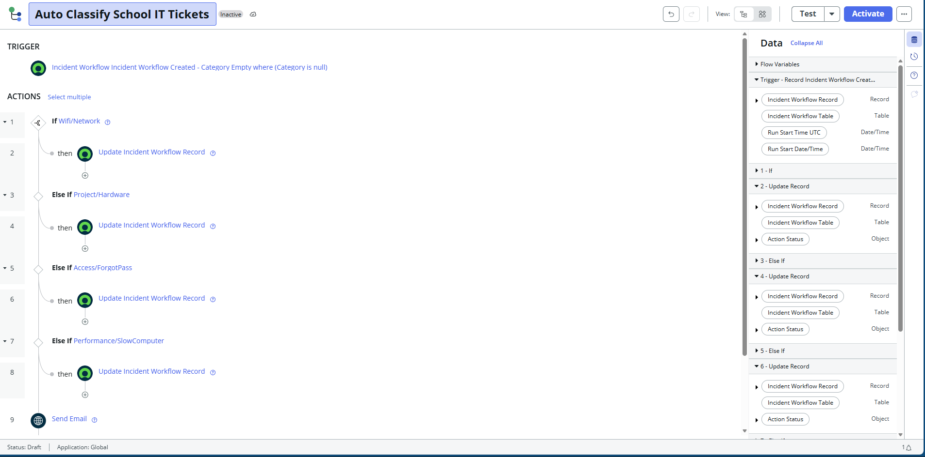
Figure 3. Implemented Flow Designer canvas showing the Record Created trigger and four classification branches.
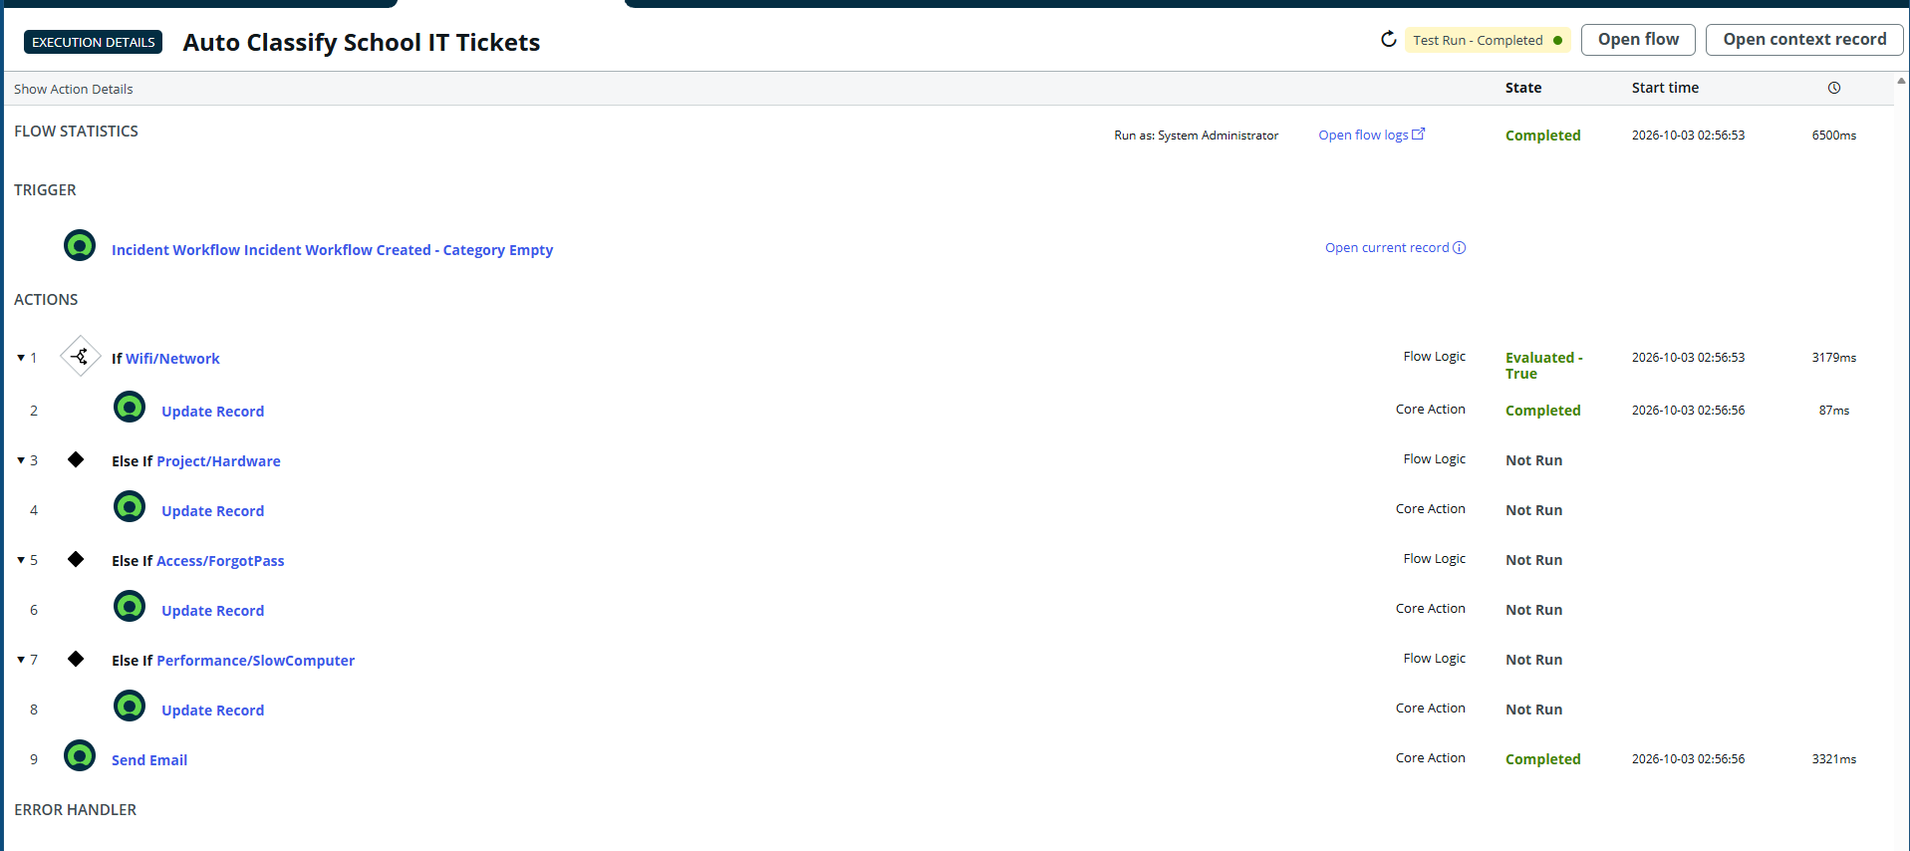
Figure 4. Captured Flow Designer execution: WiFi/Network branch evaluated True, Update Record completed, and Send Email completed.
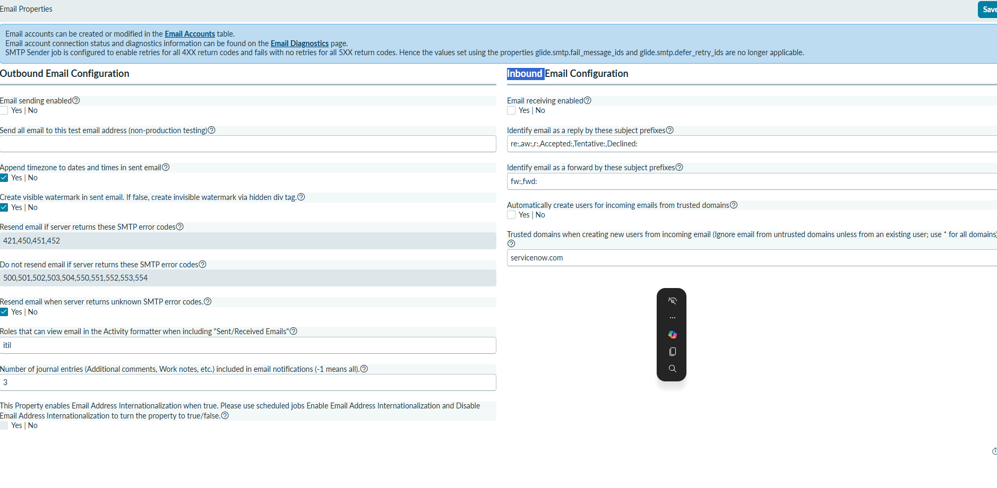
Figure 5. ServiceNow outbound email configuration showing email sending enabled for the test environment.
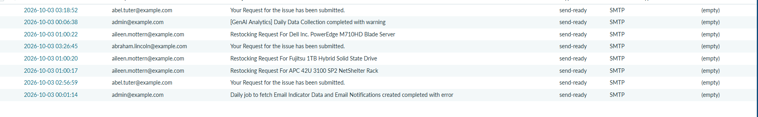
Figure 6. ServiceNow email log showing records with the required subject “Your Request for the issue has been submitted.”
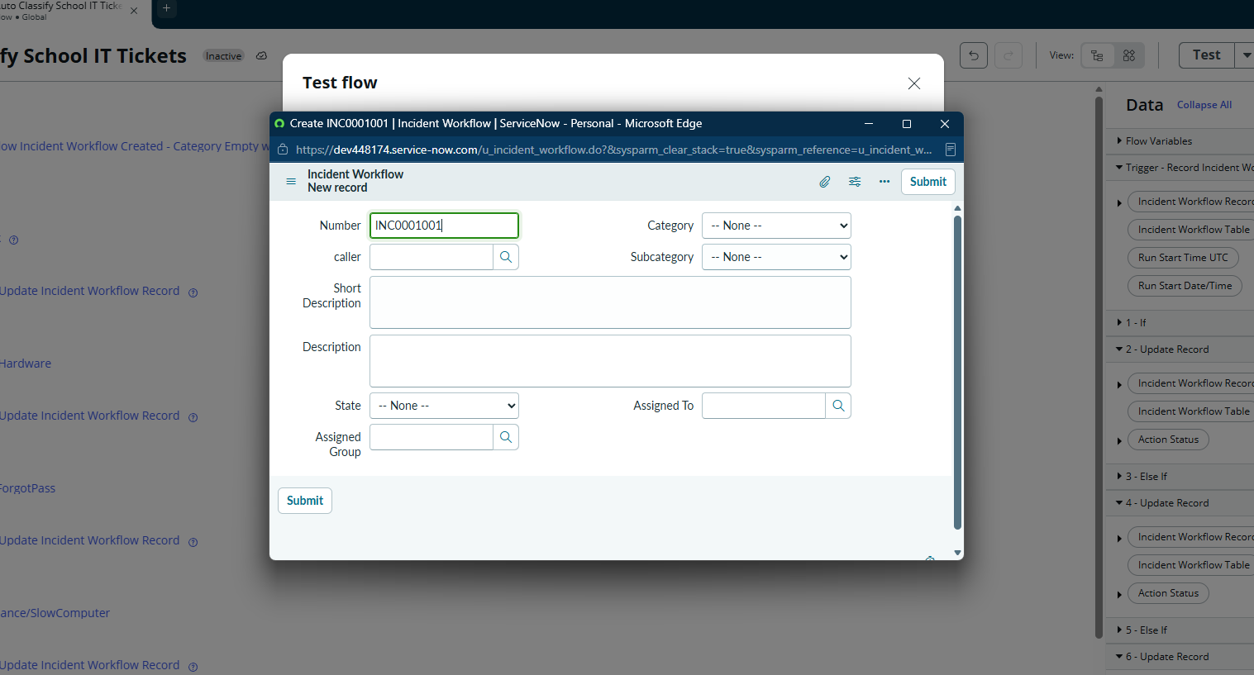
Figure 7. Incident Workflow test-record form used during flow testing; auto-number INC0001001 is visible.

7.3 Evidence Register
Evidence item | Captured / pending | Use in submission
PDI / implementation environment | Captured | Demonstrates the build environment.
Project Update Set | Complete and exported | Demonstrates configuration capture.
Incident Workflow table and fields | Captured during implementation | Demonstrates backend configuration.
Choice/dependency configuration | Captured during implementation | Demonstrates valid category/subcategory mapping.
Flow Designer canvas | Captured | Demonstrates trigger and classification branches.
Flow execution details | Captured | Demonstrates actual branch execution and action completion.
Email action/configuration | Captured | Demonstrates notification setup.
Email log | Captured | Demonstrates generated email records and required subject.
Final active Flow state | Captured | Capture after clicking Activate.
Update Set XML | Captured | Export after changing Project Update Set to Complete.
GitHub repository URL | Pending – repository is being committed | Add after final package is uploaded.
SkillWallet submission screen | Pending | Add after final submission.

8. ADVANTAGES & DISADVANTAGES
Advantages | Disadvantages / limitations
No-code implementation using Flow Designer. | Keyword rules can miss wording that was not included in the conditions.
Classification rules are visible and easy to edit. | Broad keywords can create false matches if not tested carefully.
Dependent choices improve data consistency. | No machine-learning understanding of context or intent.
Auto-numbering provides standardized ticket identifiers. | Formal load/performance testing was not performed.
Email acknowledgement can be automated. | PDI email behavior is environment-dependent; log evidence is safer than claiming external delivery.
Update Set supports configuration handover. | Keyword rules require maintenance when new wording is introduced.
Can be extended with assignment, SLA and predictive features. | Production deployment and integrations are outside the current scope.

9. CONCLUSION
The Auto Ticket Classification Using Flow Designer project implements a structured, no-code ServiceNow workflow for a school IT helpdesk scenario. The solution uses the Incident Workflow custom table, standardized choice fields, a Category-to-Subcategory dependency, and a Flow Designer automation that classifies four common issue types.
The live PDI evidence demonstrates the central workflow behavior: a newly created ticket with an empty Category triggers the active flow, the matching Wi-Fi/Network branch evaluates successfully, the ticket is updated, and the email action executes. The final real-time test confirmed that the workflow triggers from an actual record creation rather than only from the Flow Designer test runner.
The remaining submission-critical actions are operational rather than architectural: activate the flow, set Project Update Set to Complete, export the Update Set XML, verify the file, package the final report and evidence in GitHub, and submit the required links through the NM process.

10. FUTURE SCOPE
- Automatic assignment of classified tickets to support groups.
- SLA creation, tracking and escalation based on Category and priority.
- Additional keyword variants with a controlled synonym dictionary.
- A normalization step for more robust handling of case and formatting variations.
- Predictive Intelligence or ML-based classification after sufficient historical ticket data is available.
- Dashboarding for ticket volumes by category, resolution time and recurring issues.
- Integration with school identity, asset or communication systems if required in a production deployment.
- Knowledge-base suggestions based on classified issue type.

11. APPENDIX

Appendix A – Source Code
No custom source code is required for the implemented solution. The automation is built using ServiceNow Flow Designer / Workflow Studio configuration. The transferable implementation artifact is the ServiceNow Update Set XML.

Appendix B – Dataset Link
Not applicable. This project is rule-based and does not use a training dataset.

Appendix C – GitHub & Project Demo Link
Submission item | Value
GitHub repository | TO BE ADDED AFTER PUSH
GitHub project folder | Servicenow_Auto_Ticket_Classifier
Project demo / video | TO BE ADDED IF REQUIRED
SkillWallet submission | TO BE COMPLETED

Appendix D – Exact Implementation Configuration
Configuration | Value
Table label | Incident Workflow
Table name | u_incident_workflow
Auto-number | INC prefix; 7 digits; starting number 1000
Caller | u_caller → sys_user / User
Category | u_category
Subcategory | u_subcategory
Short Description | u_short_description
State | u_state
Assigned Group | Reference → Group
Assigned to | Reference → User
Update Set | Project Update Set
Update Set application | Global
Flow | Auto Classify School IT Tickets
Trigger | Incident Workflow Created; Category is null
Email subject | Your Request for the issue has been submitted.

Appendix E – Final Submission Checklist
Final action | Status
Activate Auto Classify School IT Tickets | COMPLETE
Run / capture final four classification tests as needed | CORE PATH COMPLETE; OPTIONAL EDGE CASES REMAIN
Verify email action/log evidence | COMPLETE AT ACTION/LOG LEVEL
Open Project Update Set | COMPLETE
Change State from In progress to Complete | COMPLETE
Save Update Set | COMPLETE
Export Update Set to XML | COMPLETE
Verify XML file opens / exists | COMPLETE
Update this report with final XML filename and links | COMPLETE FOR XML; GITHUB URL PENDING
Create / update GitHub repository | IN PROGRESS
Upload phase-wise templates required by NM | PENDING
Upload final report and evidence | PENDING
Add GitHub/demo links to SkillWallet | PENDING

Submission note: The supplied ServiceNow Administrator Project Guide requires completion of the phase-wise templates, upload of deliverables to GitHub, and submission of the final project/GitHub link by 3 October 2026. The common final-report template supplied in the template ZIP is reflected in the section structure of this document.

Source Basis Used for This Documentation
- Auto Ticket Classification using Flow Designer project document supplied for the ServiceNow Administrator project.
- ServiceNow Administrator – Project Guide supplied for the Naan Mudalvan track.
- Common template ZIP supplied with the project, including the Final Report Template and phase-wise templates.
- Implementation evidence captured from the project PDI during the current build and testing session.
The report does not invent unexecuted test results, external email delivery, GitHub URLs, or demo URLs. The exported Update Set XML filename is recorded exactly as captured. Optional edge-case tests and repository/SkillWallet links remain explicitly identified rather than being falsely marked complete.

FINAL IMPLEMENTATION EVIDENCE
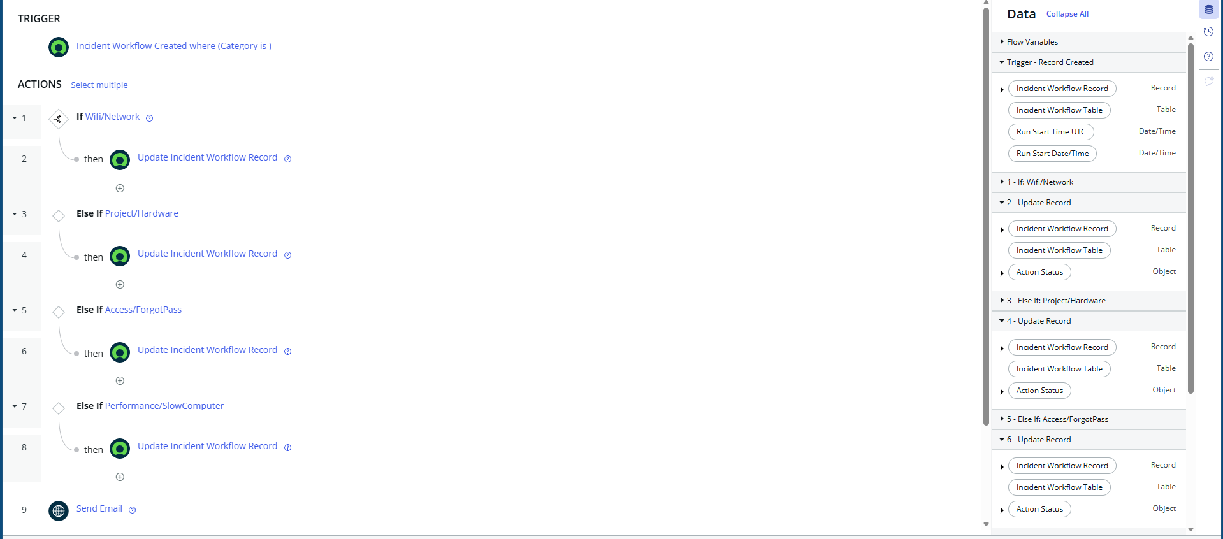
Final Flow Designer canvas after replacing the saved trigger with the standard Record Created trigger and reconnecting the action data pills.
Completed Flow Designer execution showing the Wi-Fi/Network branch evaluated True, Update Record completed, and Send Email completed.
Send Email action configuration used by the implemented workflow.
ServiceNow email log evidence showing generated notification records with the required subject.
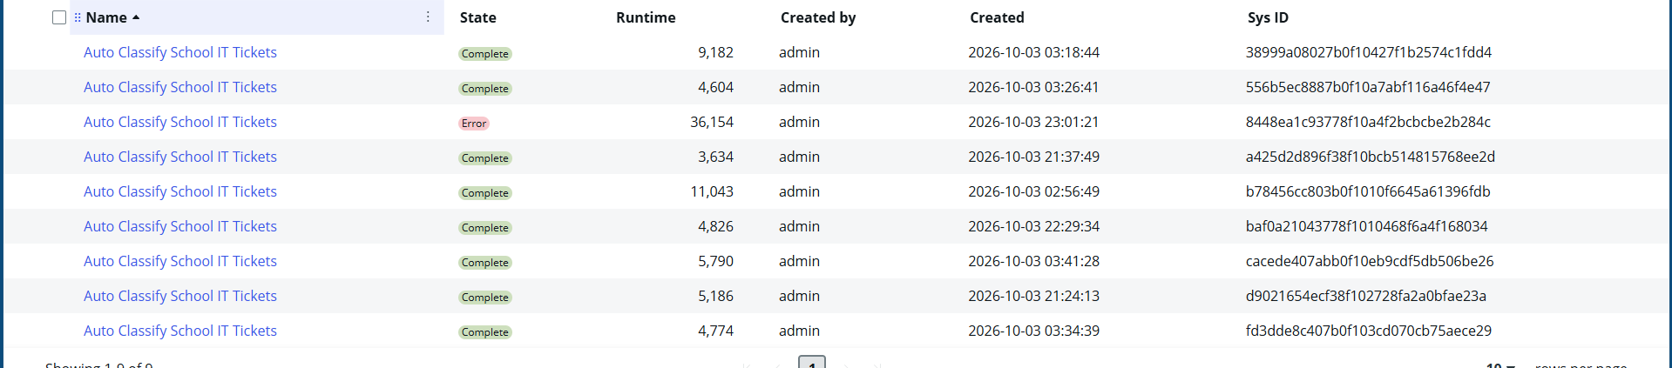
Flow execution history from the PDI. The history retains earlier diagnostic attempts as well as completed executions.
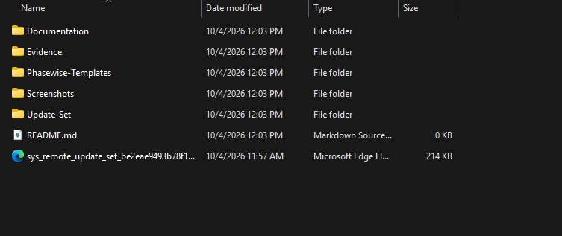
Final project folder showing the GitHub repository skeleton and the exported ServiceNow Update Set XML in the working package.

PROJECT COMPLETION
Auto Ticket Classification Using Flow Designer
ServiceNow Administrator Project | Naan Mudalvan

Project Done By
Logajit S
Manellore Kusuma Keerthi
Implementation • Testing • Documentation • Deployment Package
Final DOCX prepared for GitHub submission and PDF conversion.

